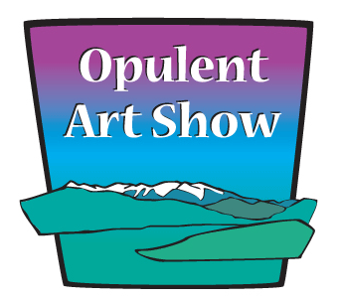
Call For Artists
Fifth Annual Opulent Art Show
Saturday, September 15, 2012 10:00 AM – 4:00 PM

WHO: Burning Down the House, a creative collective, based in Sequim and Port Angeles, Washington.

WHAT: We are hosting an event for interested artisans to give them an opportunity to sell their products, in a beautiful setting.

WHERE: The Cutting Garden located at 303 Dahlia Llama Lane, Sequim, Washington.

WHEN: Saturday, September 15, 2012. Hours are 10:00 a.m. until 5:00 p.m.
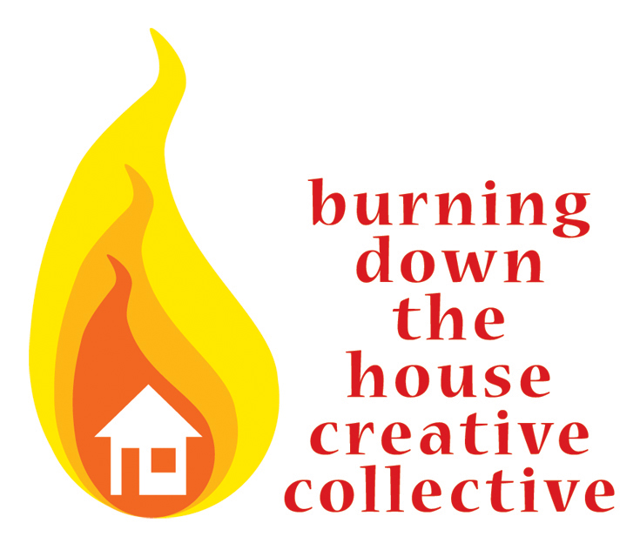
Set up begins at 7:00 a.m. Sept. 15.

FEE: Cost per vendor is $55 or $75
WEB: OpulentArtShow.com

Early Registration Deadline is April 1, 2012 to receive $10 off the fee.
We are seeking artists to participate in this annual event to showcase and sell your handmade items in a stunningly beautiful location.

- There are 8 x 6 spaces available outside on the covered wrap-around farmhouse porch, under a large event canopy, or 10 x 10 personal canopies.
- Food, wine, and musical entertainment will be at the Opulent Art Show.
- Be sure to submit your completed application as soon as possible to guarantee your space at the Annual Opulent Art Show!

Burning Down the House Creative Collective that is a local group of art businesses dedicated to encouraging education, positive professionalism, and creating inclusive and innovative opportunities. For more information, please contact Renne Emiko Brock-Richmond at renne@uniqueasyou.com / facebook.com/OpulentArtShow / facebook.com/BurningDownTheHouseCreativeCollective

2012 Opulent Art Show Vendor Application and Juried Submission

Business Name ________________________________________
WA UBI # ______________________________
Washington Business License required and vendor is responsible for sales and sales tax statement.
Contact Name _________________________________________
Street Address _________________________________________
City, State, Zip _________________________________________
Phone _______________________________________________
Email ______________________________________
Website / Blog ______________________________________
Facebook Page ______________________________________

Description of items being sold and techniques to produce them

Artist Statement

Early Registration is until April 1, 2012, $10 off the fee. Vendor Space: Outside Under Farmhouse Porch 6‘ x 8’ ___ or Event Canopy 6‘ x 8’ ___ is $55. Outside under your own 10’ x 10’ canopy ____ is $75.
Please make your check payment to “unique as you”. Please mail your payment and Hold Harmless Agreement as soon as possible to guarantee your space to Renne Brock-Richmond, P.O. Box 2633, Sequim, WA 98382. In the event that you are not selected, your check will be returned.
Please email your digital application and photos of your artwork to: Renne Brock-Richmond at renne@uniqueasyou.com
Please provide up to 3 jpeg or pdf images of your current work that you intend to sell at the Opulent Art Show for review. The preferred image size is 1024 pixels at 72 dpi with your name in the file name. For marketing purposes, we would like to have your artwork on a white background. Attach a separate file with the following information: title, size, estimated weight, and medium.

By submitting these images and artist statement, you consent to the use of the images and text in marketing and public relation materials for the purpose of promoting Opulent Art Show. Submission of images and info by April 1 is encouraged to be included in most of the promotion materials. Burning Down The House, the event organizer, reserves the right to jury the artwork to provide an event of exceptional quality and showcase the talent of the Olympic Peninsula.

All vendors must display only within their allotted space. You understand that you must bring table and table covers, as well as, canopy if you are under your 10’ x 10’ space. No early breakdowns are permitted. You will receive notification in May to be included in publicity and will receive a marketing packet to contribution in promotion of this creative and community event.
A signed and completed Hold Harmless Agreement is required. Please include it with your application. Business Insurance is highly recommended.
ALL Opulent Art Show VENDORS MUST COMPLETE AND SIGN THIS FORM. INCLUDE FORM WITH APPLIACATION AND PAYMENT.

Indemnification and Hold Harmless Agreement Opulent Art Show

September 15, 2012 10:00 a.m. until 4:00 p.m. Set-up time is 7:00 a.m. the day of the show. Location: The Cutting Garden, 303 Dahlia Llama Lane, Sequim, Washington.

For and in consideration of Opulent Art Show (therein called OAS) authorizing the undersigned to vend at the 2012 OAS, the undersigned participant does hereby agree to indemnify and hold harmless OAS for any claim or bodily injury to any person whomsoever, occurring in or upon the space reserved for all activities of the 2012 OAS, including costs and reasonable attorney fees.

Participant agrees to assume all risks and release OAS, its sponsors and volunteers from any and all liabilities from any and all claims for injuries, damage or loss, including, but not limited to, loss or damage of vendors’ property in the care, custody, or control of the vendor.

In the event OAS is named as defendant in any action covered by this indemnification and hold harmless agreement, then in such an event, the undersigned vendor does hereby agree to immediately accept the tender of said defense, defend said action, and hold OAS harmless of any liabilities thereon.

This form must be signed and returned to the vendor coordinator before entry to the OAS. Failure to do so will result in forfeiture of space and fees.
This agreement is not valid until approved by a representative of the OAS.

Dated this _____________________________ day of______________________, 2012
Print Name_____________________________________________________
Business_____________________________________________________
Address______________________________________________________
City _____________________ State ______________ Zip Code _________
Signature______________________________________________________

If you are not covered by a business insurance policy, it is strongly recommended that you purchase some sort of liability insurance to cover you, your wares and your equipment.

DO NOT SIGN BELOW THIS LINE
* * * * * * * * * * * * * * * * * * * * * * * * * * * * * * * * * * * * * * * * * * * * * * * *
Opulent Art Show 2012 Vendor Coordinator Signature:
Signed _____________________________________
Date_________________________________

